**Assignment 2**

Based on the readings, lecture slides, and materials in the Module 1, answer the below questions and submit via blackboard in a .docx or .pdf format.

To perform this assignment, you will need to use the “Sakila” database that is pre-installed. On the start screen of Valentina, you’ll see something similar to what is below. Select the first item and then click the “SQL” button in the menu on the top (note I have more objects than most students will):

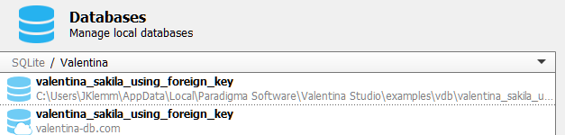

Within this database, you will be using the film table for the first assignment. Based on assignment readings and slides, perform each of the following queries from the fil table.

**Guided Queries: For the 5 following questions, your submission will be the query that you would write that would return the needed result**

1. Write a query only showing the Title of the film, and description of the film from the film table.

**SELECT**

**Title, description**

**FROM**

**film**

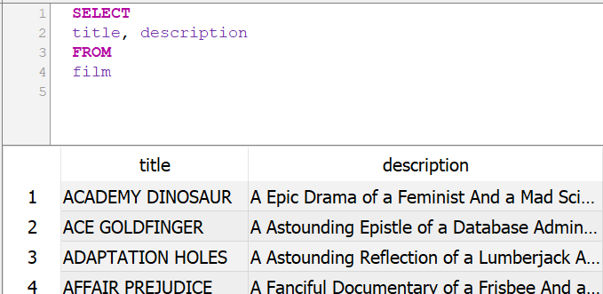

1. Write a query that returns all columns for movies that have a rating of PG form the film table.

**SELECT**

**\***

**FROM**

**film**

**WHERE rating = 'PG'**

1. Write a query that returns all columns for films that have a rental rite greater than 2.5

**SELECT**

**\***

**FROM**

**film**

**WHERE rental_rate >= 2.5**

1. Write a query that counts the number of films where the language_ID does not equal 1

**SELCT**

**COUNT (*)**

**FROM**

**Film**

**WHERE language_id <> 1**

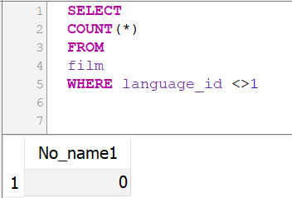

1. Write a query that returns the Title, Description, Release_Year, Rental_Duration, and Rating for films that have a title including the word “GOLD” and a description including the word “Database” and a rating of G or PG

**SELECT**

**Title, Description, Release_Year, Rental_Duration, rating**

**FROM**

**Film**

**WHERE title LIKE ‘%GOLD%’**

**AND description LIKE ‘%Database%’**

**AND rating LIKE ‘%G’**

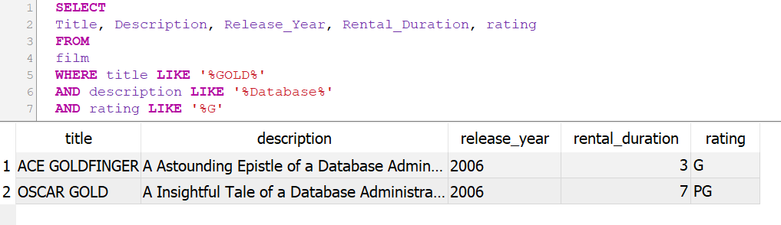

**Query Results: For the 5 following questions, your submission will be the output of the queries.**

1. How many films are rated R?

**There are 195 films rated as “R”**

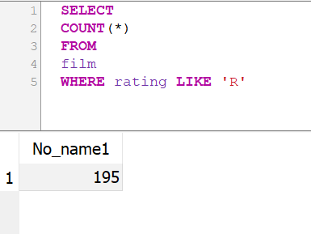

1. What is the average rental duration of all films?

**The average rental duration is 4.985**

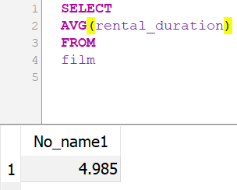

1. What is the highest replacement_cost of any film?

**Highest replacement cost is 29.99**

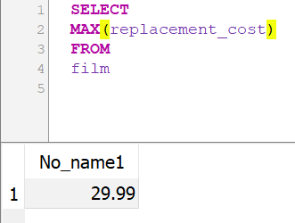

1. How many films have a rental duration of 3?

**There are 203 films with a duration of 3**

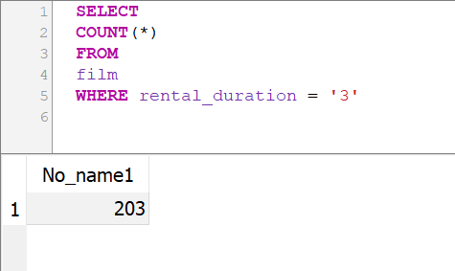

1. What film Titles have a rental duration of more than 5, a rating of R, and replacement cost of more than 20?

There are 29 films that have the titles of the above requirements as below;

